

**Mawlana Bhashani Science and Technology University**

**Lab-Report**

Report No:10

Course code: ICT-3110

Course title: Operating System Lab

Date of Performance:

Date of Submission:

**Submitted by Submitted To**

Nazrul Islam

Assistant Professor

Dept. of ICT

MBSTU.

Name: Azharul Islam

ID:IT-18052

3rd year 1stsemester

Session: 2017-2018

Dept. of ICT

MBSTU.

***Experiment No:10***

**Experiment Name:** Implementation of Round Robin Scheduling Algorithm

**Theory:**

Round Robin is the preemptive process scheduling algorithm. Each process is provided a fix time to execute, it is called a **quantum**. Once a process is executed for a given time period, it is preempted and other process executes for a given time period. Context switching is used to save states of preempted processes. It is a real time algorithm which responds to the event within a specific time limit.

**Working Process:**

#include<stdio.h>

int main()

{

int count,j,n,time,remain,flag=0,time_quantum;

int wait_time=0,turnaround_time=0,at[10],bt[10],rt[10];

printf("Enter Total Process:\t ");

scanf("%d",&n);

remain=n;

for(count=0; count<n; count++)

{

printf("Enter Arrival Time and Burst Time for Process Process Number %d :",count+1);

scanf("%d",&at[count]);

scanf("%d",&bt[count]);

rt[count]=bt[count];

}

printf("Enter Time Quantum:\t");

scanf("%d",&time_quantum);

printf("\n\nProcess\t|Turnaround Time|Waiting Time\n\n");

for(time=0,count=0; remain!=0;)

{

if(rt[count]<=time_quantum && rt[count]>0)

{

time+=rt[count];

rt[count]=0;

flag=1;

}

else if(rt[count]>0)

{

rt[count]-=time_quantum;

time+=time_quantum;

}

if(rt[count]==0 && flag==1)

{

remain--;

printf("P[%d]\t|\t%d\t|\t%d\n",count+1,time-at[count],time-at[count]-bt[count]);

wait_time+=time-at[count]-bt[count];

turnaround_time+=time-at[count];

flag=0;

}

if(count==n-1)

count=0;

else if(at[count+1]<=time)

count++;

else

count=0;

}

printf("\nAverage Waiting Time= %f\n",wait_time*1.0/n);

printf("Avg Turnaround Time = %f",turnaround_time*1.0/n);

return 0;

}

**Output Sample:**

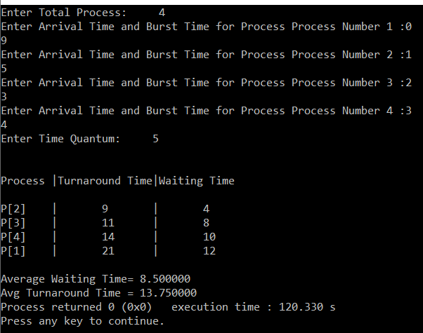

**Discussion:** To learn Round Robin scheduling algorithm, this lab helped a lot. We learnt this topic and now we can implement these further.